**Game Design Document: Cut the red!**

**Game Concept**

*Cut the red!* is a 3D puzzle game designed exclusively for the PlayStation 5's DualSense controller. Players are tasked with defusing a virtual bomb by interacting with various modules, each requiring the use of different sensory inputs: haptic feedback, adaptive triggers, motion sensing, and microphone input. The game challenges players' abilities to perceive and interpret sensory cues to successfully defuse the bomb.

**Target Audience**

The game is designed for players who enjoy immersive and sensory-rich gaming experiences, especially those who own a PlayStation 5 and are eager to explore the unique capabilities of the DualSense controller. The target audience includes both casual and hardcore gamers.

**Game Mechanics**

**Sensory Modules**

The game features a variety of bomb modules, each with unique sensory challenges. Some examples include:

* **Haptic Labyrinth**: Players navigate a maze by feeling vibrations that guide them and avoid walls by sensing vibrations intensify as they get closer to obstacles.
* **Adaptive Wire Cutting**: Adaptive triggers simulate tension while players carefully select the right wire to cut.
* **Balance Challenge**: Utilizing the built-in motion sensor, players must maintain balance while performing precise tasks.
* **Audio Clues**: Some modules require players to rely on sound cues picked up by the controller's microphone, like deciphering morse code or identifying frequencies.

**DualSense Controller Integration**

The game fully utilizes the DualSense controller's features, including haptic feedback, adaptive triggers, motion sensing, and the microphone, similar to how "Astro's Playroom" showcases the capabilities of the controller. Each module is designed to make the player feel as if they are physically interacting with the bomb, enhancing immersion.

**Gameplay**

Players must defuse a series of bomb modules to successfully complete the level. Each module introduces new challenges, ensuring a steady learning curve and keeping gameplay engaging. Challenges include tactile puzzles, delicate trigger control, balance tasks, and sound-based puzzles. Game consists of series of bombs with different complexity and players will need to master their skills to defuse the bomb effectively and complete the game.

**References**

* Keep Talking and Nobody Explodes
* 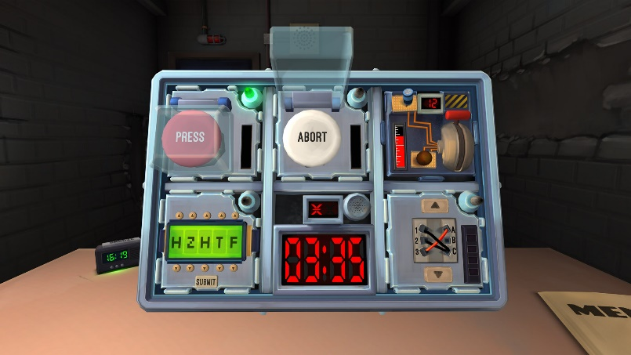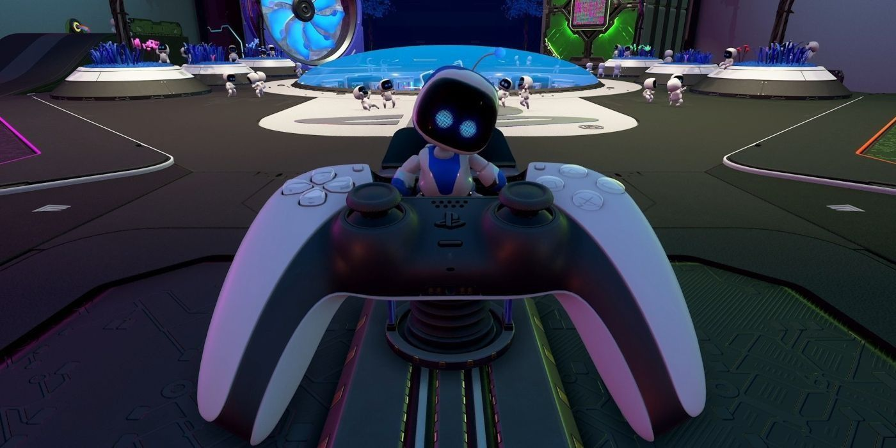Astro’s Playroom

